COMMUNITY PLANTREE: Building Resilience, Growing Abundance
A Concept Paper

Introduction
COVID-19 pandemic brought drastic changes in our lives. Unemployment rate surges because of long-term lockdown leading to poverty, starvation and chaos. Many of us are not prepared for this situation making us vulnerable and confused. Every day we battle the question of how to survive another day and what can we do to help others.
Even before pandemic badly hits the world, there are increasing numbers of people who are engaged in different farming systems claiming to be self-sustaining. We, at Glorious Land Ecofarm tried some of these different farming systems until we came across Permaculture. This system design is a holistic approach that adopts what is present in natural ecosystems and uses principles of regenerative agriculture, reforestation using indigenous trees and community resilience. Permaculture served us its purpose during the pandemic. It provides food, energy, and even mental wellness without the need to leave our place. Having these provisions in our own home makes us resilient not just during this pandemic but also from natural calamities that may come. We had plans to go out, promote awareness and influence communities to adopt Permaculture design system but were derailed due to this pandemic. With the emergence of community pantries, we are able to envision how we can proceed. Together with our stakeholders and volunteers from different sectors of our community, we can have a better chance of rebuilding our lives and surviving whatever calamities or pandemic sets in.
Project Description
Our concept includes three major components: Pantry, Plantry and Plantree.
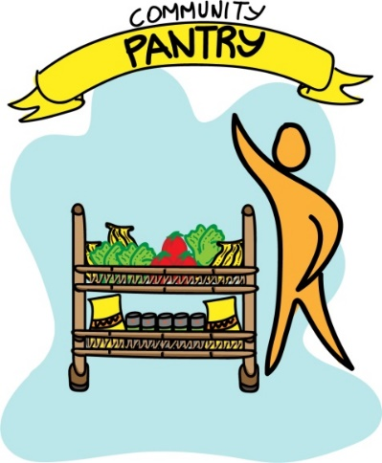
Pantry is the initial community engagement, which shows our natural instinct to care for one another. At this stage, we hope to provide immediate basic needs of the target communities (e.g. food, toiletries, etc.). Pilot communities for 3Ps will be identified and validated. In partnership with our sponsors and volunteers, pledges will be brought to designated barangay pantry to serve its purpose.
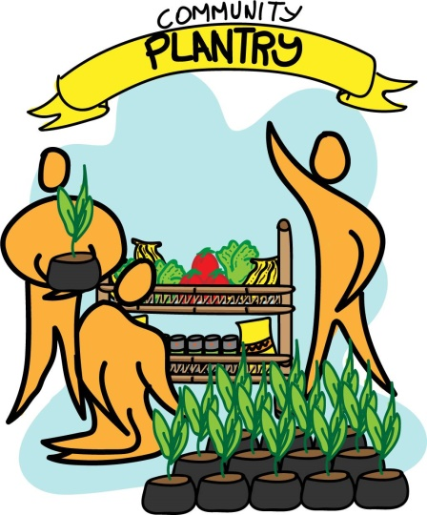
The second phase is Plantry. In this phase beneficiaries will be encouraged to grow their own food, either in their backyard or community gardens. Initial seedling materials will be provided by partner organizations and institutions. There shall be demonstration of cultural management practices and home-based fertilizer production integrated during Pantry activities. Aside from this, alternative livelihood shall be developed, preferably from regenerative resources in the area. This can be made possible by establishing partnership with government institutions, NGOs and private individuals.
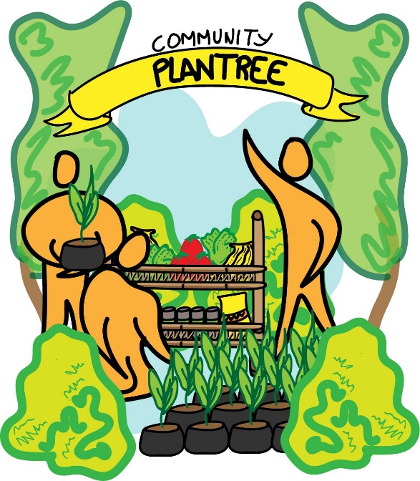
The third phase is Plantree. This is the ultimate goal of the program. In this phase, we aim to empower communities to care and develop harmonious relationship with mother Earth. It begins with understanding nature, importance of biodiversity and how we can be part of this ecosystem. A series of Permaculture trainings and seminars shall be conducted to develop and strengthen this relationship. At the end of the project, the selected communities shall be protecting the environment, resilient and self-sustaining through unlimited abundance provided by nature.

“Give a man a fish and you feed him for a day, teach him how to fish and you feed him for his life time.” — Italian proverb.

